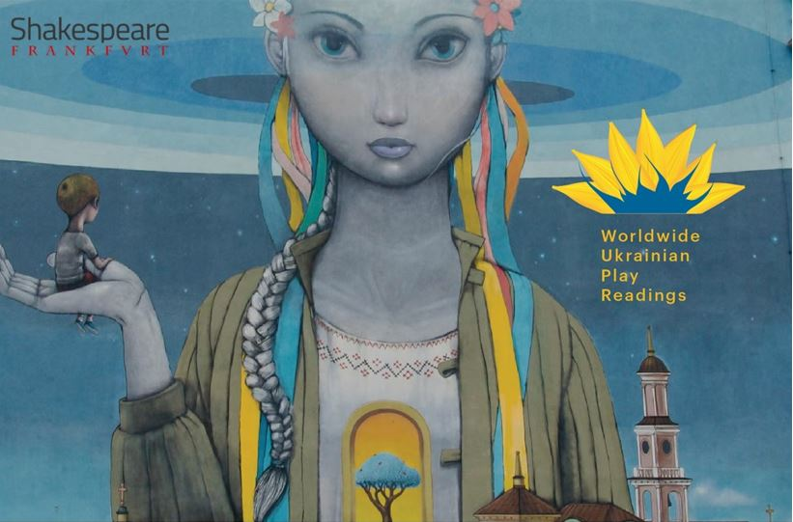
Shakespeare Frankfurt, the Worldwide Ukrainian Play readings
and the Go West Festival present
REFLECTIONS
August 7, 2022
Performers:
Ioanna Moudanioti – music Renard Yearby – poetry
Anna Rogers, Varvara Pomoni and Jim Phetterplace Jr. – Play readers

ACT 1
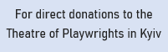
Romeo and Juliet by Sergei Prokofiev
I Want to Go Home by Oksana Savchenko
Thing We Lost in the Fire by Renard Yearby
Gnossienne No.1 by Erik Satie
Standing in front of the mirror or what I say to myself
before I leave the house by Renard Yearby
Call Things by Their Names by Tetiana Kytsenko
ACT 2
Butterfly by Ioanna Moudanioti
Peace and Tranquility by Andriy Bondarenko
Empty of You by Renard Yearby
A Dictionary of Emotions in War Time by Elena Astaseva
Our Last Conversation by Renard Yearby
Clair de Lune by Claude Debussy

www.shakespearefrankfurt.de

