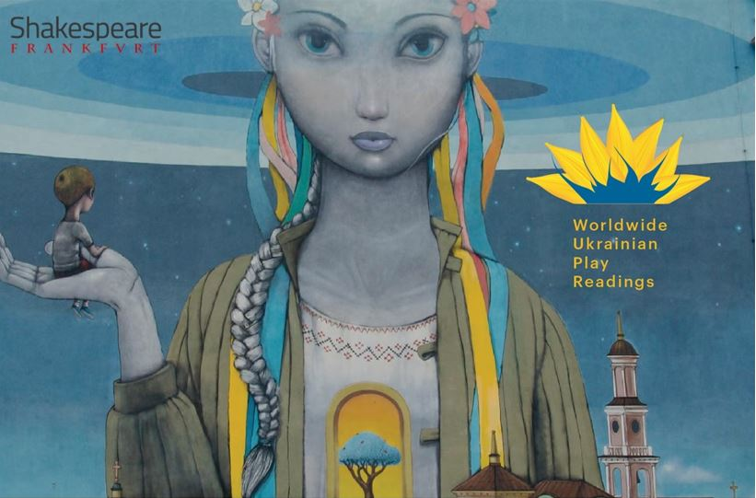
Shakespeare Frankfurt, the Worldwide Ukrainian Play readings
and the Go West Festival present
REFLECTIONS
August 21, 2022
Performers:
Ioanna Moudanioti – music Renard Yearby – poetry
Anna Rogers, Varvara Pomoni and Jim Phetterplace Jr. – Play readers

ACT 1
Gnossienne No.1 by Erik Satie
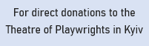
In the Darkness by Natalia Blok
Thing We Lost in the Fire by Renard Yearby
Dialogues by Tasia Pugach
Butterfly by Ioanna Moudanioti
Standing in front of the mirror or what I say to myself
before I leave the house by Renard Yearby
Call Things by Their Names by Tetiana Kytsenko

ACT 2
Romeo and Juliet by Sergei Prokofiev
I Want to Go Home by Oksana Savchenko
Empty of You by Renard Yearby
My Tara by Liudmyla Tymoshenko
Our Last Conversation by Renard Yearby
Clair de Lune by Claude Debussy

www.shakespearefrankfurt.de

