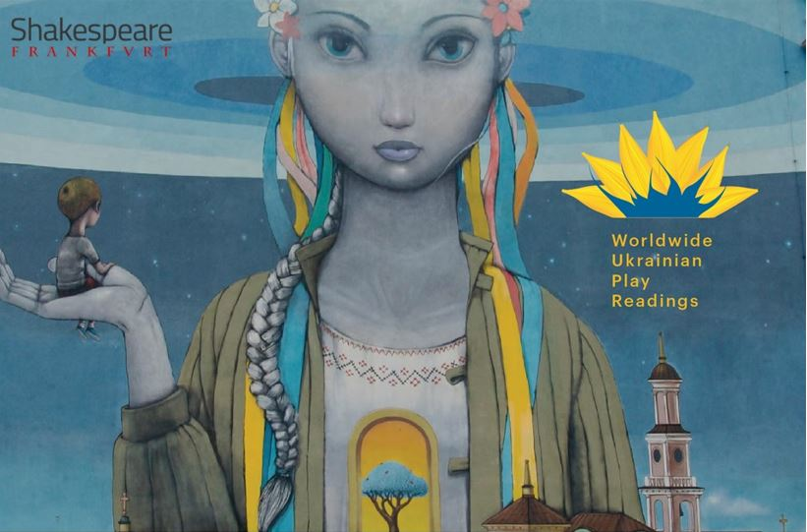
Shakespeare Frankfurt, the Worldwide Ukrainian Play readings
and the Go West Festival present
REFLECTIONS
August 14, 2022
Performers:
Ioanna Moudanioti – music Renard Yearby – poetry
Anna Rogers, Varvara Pomoni and Jim Phetterplace Jr. – Play readers

ACT 1
Gnossienne No.1 by Erik Satie
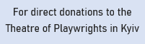
In the Darkness by Natalia Blok
Thing We Lost in the Fire by Renard Yearby
Romeo and Juliet by Sergei Prokofiev
What is War? by Andriy Bondarenko
Dialogues by Tasia Pugach
Standing in front of the mirror or what I say to myself
before I leave the house by Renard Yearby

ACT 2
Butterfly by Ioanna Moudanioti
My Tara by Liudmyla Tymoshenko
Empty of You by Renard Yearby
Peace and Tranquility by Andriy Bondarenko
Our Last Conversation by Renard Yearby
Clair de Lune by Claude Debussy

www.shakespearefrankfurt.de

